**TASIKKU**



Application of Tasikmalaya Tourism and Culinary Information System Based

on Android

Name Group :

* Muhammad Alfikri (1800018249)
* Daffa Rahmad (1800018294)
* Husniah Arief (1800018240)

**USER REQUIREMENTS**

User requirements are what users want to achieve by using software functions. According to [3] user needs describe goals and tasks (tasks) that must be achieved and can be done by the user by using software developed.

From our group's discussion of a number of potential users and reading some literature we found the following user needs and functional needs.

* About the Tasikmalaya Region
* Travel Info
* Food Info
* Ticket Price

**View Menu View Regional Place**

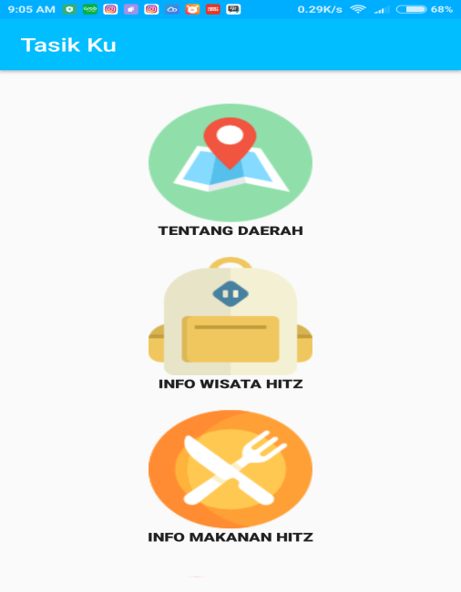 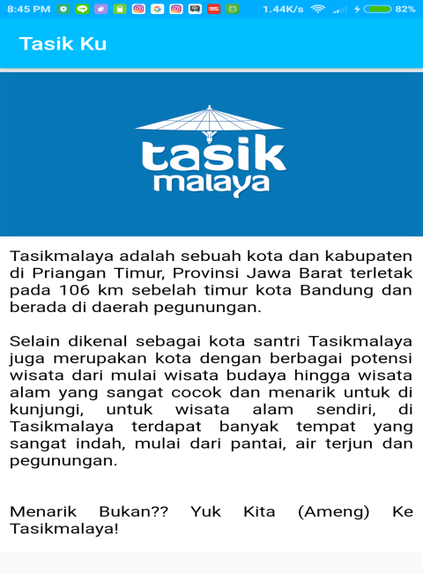

**View Tourist Attraction View Ticket Price**

